**BS. INFORMATION TECHNOLOGY**

**PDL MANAGEMENT SYSTEM**

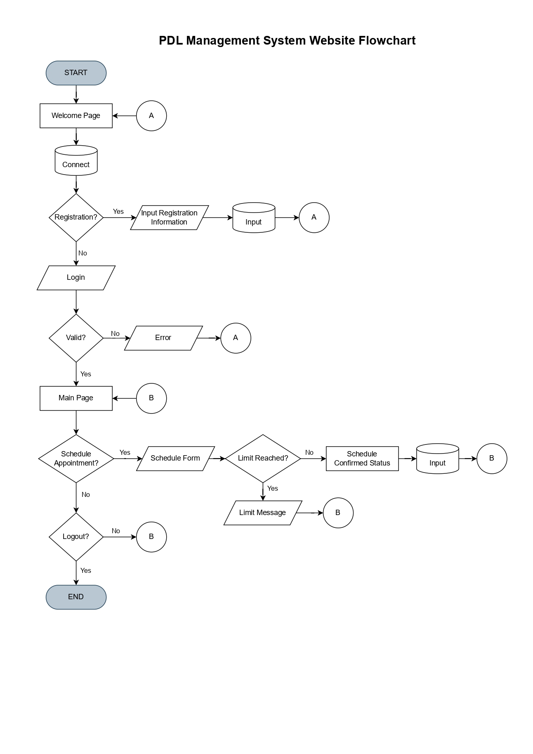**WEBSITE FLOWCHART**

Prepared by:

**JUSTINE NORIE B. DELA CRUZ**

Checked by:

**MARJON D. UMBAY**